Instant Reaction Reflection Sheet
Guarding Against Confirmation Bias

When you encounter a news headline, ask yourself the following questions to consider how your biases could impact your judgment of the information.

- What claim does the headline make?

- What is my initial reaction to the headline?

- How does it make me feel or think?

- What do I already know about the topic?

- How strongly do I hope the claim is true?

- How strongly does the claim confirm something I already believe?

- Overall, how believable is the claim?

SCALE
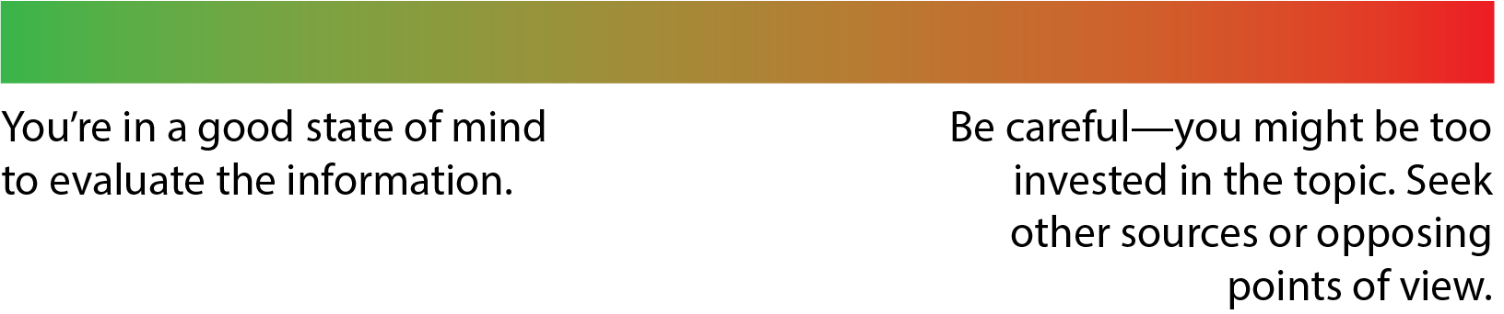

“People just have to decide, I mean, do they want to be informed or do they want to read something that makes them comfortable? [T]hat’s really what it comes down to: Do you want to be comfortable, or do you want to be informed?”
—Koran Addo, St. Louis Post-Dispatch

© Thoughtful Learning From the minilesson Guarding Against Confirmation Bias

