Advertising a Product
Revising to Appeal to Readers
Student: |  | Date:
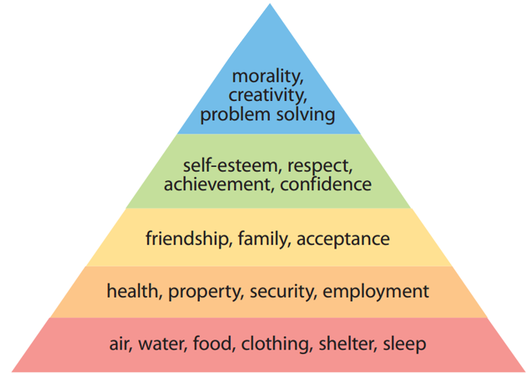
Connect to readers’ needs.
Answer the following questions to think of ways your product helps readers.

- How does your product connect with readers' basic needs (bottom-level)?

- How does your product connect with readers' intermediate needs (middle three levels)?

- How does your product connect with readers' upper-level needs (top triangle)?

- Choose three needs from the list above. For each one, write a sentence that appeals to your reader, showing how the person benefits from the product.

Revise to appeal to needs.
If one or more of the appeals you wrote in the last activity would strengthen your advertisement essay, revise to include these new connections.

© Thoughtful Learning From Write on Course 20-20 and Advertising a Product

