Practice Test for Reading and Writing Nonfiction
Nonfiction Assessment I
Closely read and respond to source 1.
Student: |  | Date:

The Undercover Wonder
by Phillip Korver
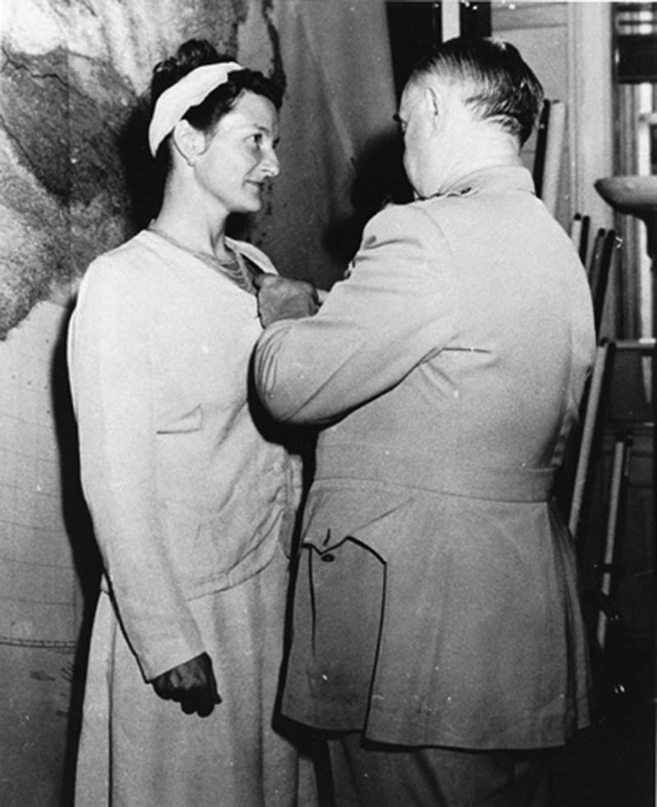
Virginia Hall receiving the Distinguished Service Cross in 1945 from OSS chief General Donovan (CIA.gov)
1 Given that Virginia Hall dedicated her life to avoiding detection, it isn’t surprising that her name is unknown to most Americans. During World War II, when most women skillfully filled wartime vacancies on the American home front, Hall worked in Europe as a spy for the Allied forces. Through her clandestine efforts, Hall saved lives, relayed enemy positions, and earned a top spot on the Gestapo’s most wanted list.
Early Career
2 Hall was at the epicenter of World War II before the first shots were even fired. She left the United States in 1926 in hopes of a career in foreign affairs, but her career goal was sidetracked when her lower left leg needed to be amputated after a hunting accident. Undeterred, Hall worked in clerical positions in Turkey and Italy, and then volunteered as an ambulance driver in Paris as Nazi Germany seized control of the city. When the French surrendered Paris, Hall fled to London, where she worked in the American Embassy. There she gained the attention of the British Special Operations Executive (SOE), and so began Hall’s career as a spy.
WWII
3 The SOE was seeking candidates to do uncover work to aid the French troops. Hall, despite her wooden leg, filled the bill. In 1941, she became the SOE’s first female operative sent into France. She traveled to Nazi-controlled Lyon, France, under the guise of a reporter for the New York Post. For the next 14 months, she worked as a spy for the British government and the French Resistance, all while writing newspaper stories to maintain her cover. Her actions eventually gained the attention of the Nazi Secret State Police, or Gestapo. The Gestapo even printed wanted posters with Hall’s likeness. When the United States joined the war, the danger of being an American “newspaper woman” in Nazi-controlled territory was too great, and Hall fled to Spain.
4 After doing SOE undercover work in Spain, Hall returned to London and joined a new American agency: the Office of Strategic Services (OSS), the precursor to the CIA. Hall requested reassignment to Nazi-occupied France, and the OSS obliged. Because of the Gestapo’s familiarity with her appearance, Hall disguised herself as an elderly milkmaid, donning a white wig and an ill-fitting dress. She trained battalions of French Resistance fighters, coordinated parachute supply and aid drops, and relayed Nazi positions to London. When the Nazis retreated, Hall’s teams blocked their path by blowing up bridges, destroying train tracks, and capturing hundreds of enemy soldiers.
Post-WWII
5 Hall is credited with saving the lives of countless Allied troops. She became the only civilian woman to receive the OSS’s Distinguished Service Cross during World War II. When she returned to the U.S., she worked for the CIA. Only recently did the CIA release details of her heroism to the public. Despite her hard work to maintain anonymity, Virginia Hall ought to be remembered among the famous U.S. heroes of World War II.
- Which statement best describes the essay’s thesis?
- Virginia Hall fought bravely for the Allies despite her physical impairment.
- Most people think of spies as men, but women have also worked bravely undercover.
- Virginia Hall deserves to be recognized among the U.S. heroes of World War II.
- Through persistence and determination, women can do anything that men can do.
- Which statement best explains the effect of the hunting accident on Virginia Hall's service as a spy?
- Overcoming her injury inspired Virginia Hall to serve her country.
- She did not allow it to deter her.
- Virginia Hall used her wooden leg along with a white wig and ill-fitting clothes to disguise herself as an elderly milkmaid.
- The hunting accident set Hall back many years in her career.
- In the first paragraph, use context clues to select the best definition of “clandestine.”
- Kept secret or done secretively
- Illegal
- Done in disguise
- Used for military purposes
- In the second paragraph, use context clues to select the best definition of "epicenter."
- Simulation of a real-world location
- The central focus of a key activity
- A safe-house for spies
- The command center
- In the third paragraph, use context clues to select the best definition of the idiom "filled the bill."
- Paid the price
- Was exactly what was needed
- Wrote a recommendation
- Wrote a resignation
- Infer the best topic sentence for the fourth paragraph.
- Virginia Hall was a master of disguises.
- The OSS was one of the first spy agencies to employ women.
- The Gestapo couldn't track down Virginia Hall.
- Virginia Hall carried out many dangerous and crucial missions in France.
- Infer why the CIA would not recognize Virginia Hall's contribution until recently.
- The CIA did not want to reveal that it had used a female spy.
- Her status as a spy was only recently declassified.
- The CIA wanted to protect Hall from the Gestapo.
- Hall's identity was not revealed until the OSS became the CIA.
- What do the photo and caption reveal about the career of Virginia Hall?
- The OSS recognized her tremendous contribution to the war effort.
- General Donovan took credit for her accomplishments.
- The Distinguished Service Cross went to only one civilian in World War II.
- Virginia Hall had a long career with the CIA.
- What statement best describes the purpose of this article?
- To argue for more women serving as spies
- To explain the heroic, secret accomplishments of an American hero
- To advocate for the service of Americans with disabilities
- To show how Allied spy services collaborated during World War II
- Select the best alternate title for this selection.
- Overcoming Prejudice to Serve
- The "Hall" of Fame
- The Unsung Hero Virginia Hall
- Milkmaid on a Mission

