Reading and Writing for Assessment
Read Closely
Student: |  | Date:

Read the following article. Then answer the 5 W’s and H about it, rereading as necessary.

Keeping Track of Goats
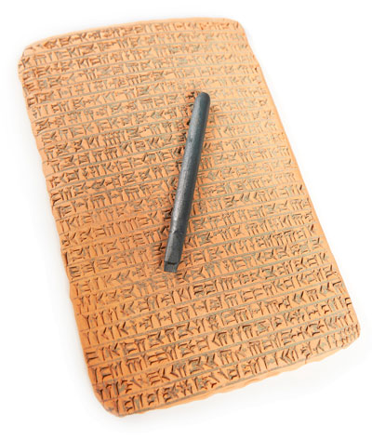
Why did writing get invented? To recount the exploits of great heroes like Gilgamesh and Odysseus? No, those epics are only 3,000 to 4,000 years old. To inscribe the laws of the land, as in the Code of Hammurabi? That's another good guess, but it wasn't the first reason. Writing began 5,000 years ago because of goats.
Imagine that a goatherd in the Fertile Crescent wanted to sell some goats to a rich buyer in some port along the Mediterranean. Let's say he drove his herd of 53 goats onto a ship to be delivered to his client. Now let's imagine that the ship arrived with 52 goats. The buyer paid for 52 and sent the cash back. Then the ship returned to the original dock, and the captain handed off payment for 51 goats. There's an obvious problem. The captain apparently ate one goat on his outward journey and pocketed the payment for another goat on his way back. What was a poor goatherd to do?
Akkad empire cuneiform on brown clay with sharpened writing tool (Couperfield, Shutterstock)
Write, that's what. The earliest form of writing, cuneiform on clay tablets, recorded the number of goats and carpets and vessels of wine sent for trade to distant ports. A merchant (or, more likely, a literate priest) counted each item in the shipment and used a sharpened stick to note them on a slab of clay, which was baked and sent along with the shipment. Another priest at the other end read the clay manifest and counted the goats and made the captain pay for any difference. Yes, writing was developed as a tool for businesses to keep track of shipments, inventories, and payments. It was a semi-magical way that a goatherd could speak to a client hundreds of miles away, letting them do business.
That practical business tool transformed human civilization. It marked the shift from prehistoric times (before written records) to modern times. Writing has come a long way since the days of clay tablets. Now we have emails, Facebook statuses, tweets, and texts, not to mention stock exchange tickers that robots can read faster than we can. But all of these advances in writing still perform the same basic magic as the cuneiform tablets. They let people talk to others hundreds or thousands of miles away, doing business, sharing ideas, and even describing a fabulous panini with sundried tomatoes and goat cheese. The medium of writing has changed thousands of times over the intervening years, but the point remains largely the same: keeping track of goats.
Rob King is a staff writer for Thoughtful Learning, developer of writing instructional materials.
- Who wrote this?

- What is it about?

- Where does the topic take place?

- When does it take place?

- Why is the topic important?

- How does the writer convey the ideas?

